../Desktop/scale.emf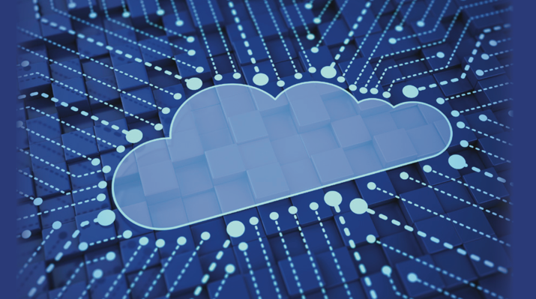

Stephen.silver@comprehensive-tel.com

866-225-8750

Contact Us To Learn More!

FEATURES

**Build at Google Scale**

Google Cloud Platform enables developers to build, test and deploy applications on Google’s highly-scalable and reliable infrastructure.

**Global Network:** Google has one of the largest and most advanced computer networks to deliver fast, consistent and scalable performance

**Redundancy:** Data is automatically mirrored   
across storage devices in multiple locations   
around the globe

**Scalability:** Applications hosted on Cloud Platform can automatically scale up to handle demanding workloads and scale down when traffic subsides, pay only for what you use

**Integration:** Build the way you want. Google integrates with familiar development tools to make it easy to build within Google Cloud Platform

**Innovation:** Google’s constant innovations in software infrastructure allow you to Access Google’s technology innovations faster

**Versatility:** Mix and match to meet your

business needs. Flexible virtual machines and a fully managed platform allow for greater computing, services and storage options

**Functionality:** Use Google APIs and services to quickly enable a wide range of functionality for your application. You don’t need to build these from scratch, just take advantage of easy integration within Cloud Platform

Google’s infrastructure is built upon the same platform that allows the return of billions of search results in milliseconds, delivery of 6 billion hours of YouTube video per month and storage for 425 million Gmail users.

Google Cloud Platform (GCP) is a portfolio of cloud-based services built on the most comprehensive infrastructure in the world. With the versatility and scalability of the Google Cloud, your business can create anything from a simple website to the most complex applications.

BENEFITS

CONTACTUS

GOOGLEDRIVEPLATFORM

SCALE TO MILLIONS OF USERS WITH UNPARALLELED PERFORMANCE

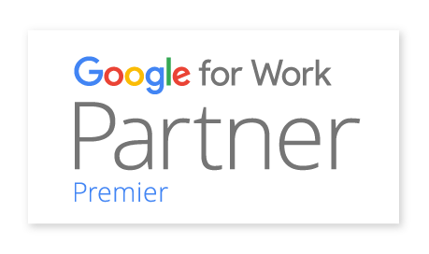

Stephen.silver@comprehensive-tel.com

Scalability is critical and with Google Cloud Platform, we can have 5,000 people using WISE at the same time without compromising any functionality.

866-225-8750

Founded in 2000, SADA Systems, Inc. is a privately-held global leader in providing cloud computing and strategic IT solutions to organizations worldwide. As a Google for Work Premier Partner, SADA Systems has proven expertise in enterprise consulting, cloud platform migration, custom application development, managed services, user adoption and change management.

Named Global Partner of the Year for Google Maps for 2014   
and 2015, as well as 2013 North America Partner of the Year for Government, SADA has a successful track record of delivering all Google for Work cloud solutions, including Google Apps, Google Drive for Work, Google Cloud Platform, Chrome, Google Search for Work, and Google Maps for Work.

Avi Badwal,

Senior Director of Technologies,

University of San Diego

AFEWOFOURCLIENTS

ABOUTSADASYSTEMS

CONTACTUS